**Program 16: Demonstrate the file operations create, read, write and delete**

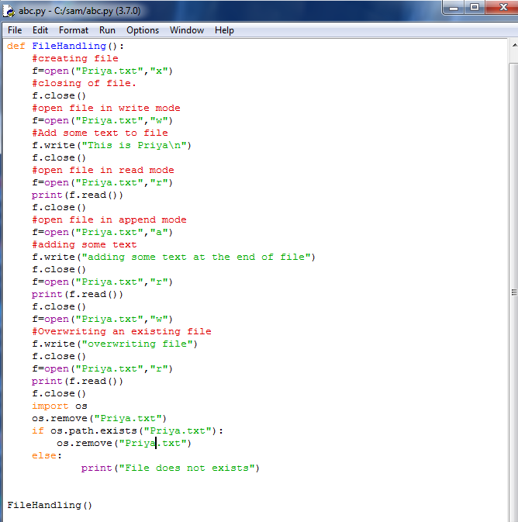

**Output:**

